3.12.1 Search Activity – Finding patent family members

Imagine you went on a canal boat trip recently. As you were cleaning the boat at the end of the journey, you wondered how to clean the part of the boat submerged under the water. Being unable to sleep one night, you perform a patent search and find an interesting document published as European Patent EP1343682.

See if you can find in which other countries or regions the patent has been applied for.

Answer Search Activity
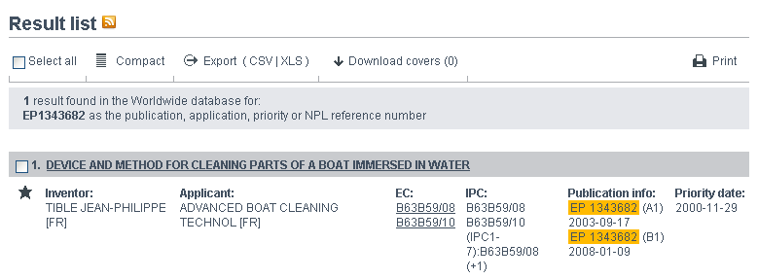
Go to Espacenet and search for EP1343682. Click on the title and then select INPADOC patent family, which gives a list of ten family members.
